

Come Shop AND Eat at Crossroads Plaza

and EARN money for our school!

Sunday 11/29 – Saturday 12/5

Shop at

for great value on Holiday gifts, such as Secret Santa gifts, Stocking Stuffers, Middle Creek Holiday Helpers’ gifts, thank you gifts and more! Everything in the store is priced $1-$5!

A portion of all sales the entire week will go to Middle Creek Elementary

***PLUS***

Take a break from shopping to enjoy food from **Jason’s Deli** and **Dickey’s Barbecue** **Pit** restaurants – BOTH will be donating a percentage of sales, too! Please bring in the coupons below for the donations to count – we encourage you to print and use as many as you like during the week!

Please submit this coupon for a percentage of your purchase to be donated to **Middle Creek Elementary**

Promotional Hours only: 5:00pm - 10:00pm;

Jason’s Deli, Crossroads Plaza, 210 Crossroads Blvd, Cary, NC 27518; 919-233-6901

Weekdays ONLY – 4:00 - 9:00pm

Monday 11/30 -- Friday 12/4/15

Weekdays ONLY – 5:00 -10:00pm

Monday 11/30 -- Friday 12/4/15

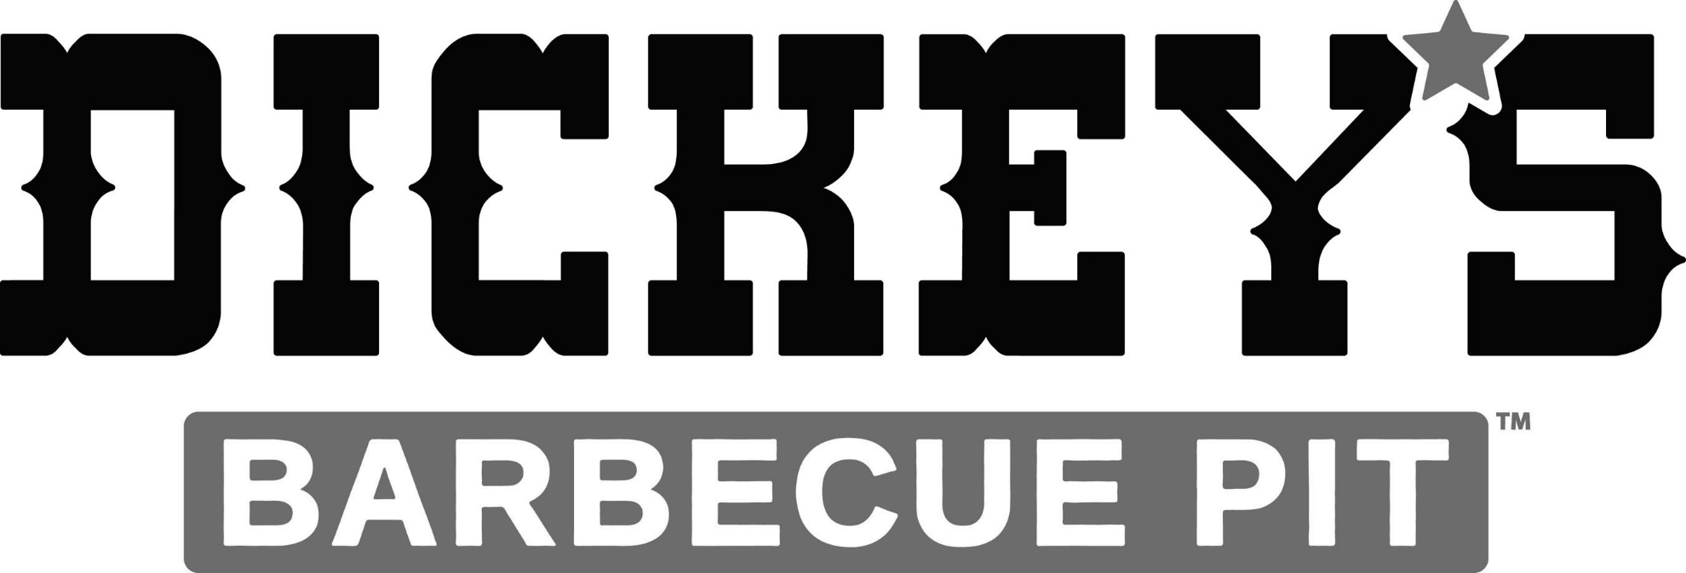



Please submit this coupon for a percentage of your purchase to be donated to **Middle Creek Elementary**

Hours: Sunday 11:00am - 7:00pm; Mon-Sat 10:00am - 9:00pm

Five Below, Crossroads Plaza, 233 Crossroads Blvd, Cary, NC 27518; 919-851-5674

Please submit this coupon for a percentage of your purchase to be donated to **Middle Creek Elementary**

Promotional Hours: 4:00 - 9:00pm;

Dickey’s Barbecue Pit, Crossroads Plaza, 200 Crossroads Blvd, Cary, NC 27518; 919-233-5801

ALL 7 Days

Sunday 11/29/15

thru

Saturday 12/5/15

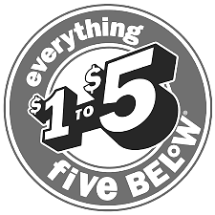

7days of

Shop. Eat. Middle Creek.













